**FORMAN CHRISTIAN COLLEGE (A CHARTERED UNIVERSITY)**

**Department of Computer Science**

**COMP 468(A) ASSIGNMENT # 1**

**SMART RIDE SHARING SYSTEM**



**JOSHUA SADAQAT [240-545460]**

**Instructor: Mr. Adeem Akhtar**

Session 2020-2024

**OBJECTIVE**

The goal of this project is to create a **Smart Ride-Sharing System** using Kotlin. The system allows for the management of **drivers**, **riders**, and **ride requests**. The application automatically matches riders with available drivers based on **proximity**, simulates traffic conditions, calculates estimated ride times, and allows riders to rate drivers after completing rides.

**PROJECT STRUCTURE**

The system is divided into several classes, each responsible for specific parts of the functionality. Below are the key components:

1. **Main.kt**: Contains the user interface (console-based) for interaction.
2. **RideSharingSystem.kt**: Handles the core logic of assigning rides, managing drivers and riders, and updating ride status.
3. **Driver.kt**: Represents a driver with attributes such as location, availability, and rating.
4. **Rider.kt**: Represents a rider with attributes such as current location, destination, and request status.
5. **Ride.kt**: Represents the ride between a rider and an assigned driver.
6. **Utils.kt**: Contains utility functions like the Haversine formula (to calculate distances between coordinates) and traffic simulation.

**EXPLANATION OF CLASSES AND FUNCTIONS**

**Main.kt** **– User Interface**

This file handles user interaction with a **console-based menu**. Users can:

* Add new drivers and riders to the system.
* Request rides.
* Display drivers and riders.
* Rate drivers after a ride.
* Exit the system.

**Menu-driven interface**

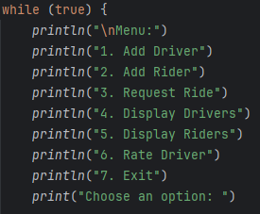

The **menu** allows users to repeatedly choose different actions until they decide to exit. This is handled using a while loop that continues until the user selects the exit option.

**RideSharingSystem.kt**

This class handles the **core logic** of the system, including adding drivers and riders, assigning rides, and updating driver ratings.

**Key Methods:**

1. **addDriver (driver: Driver)**: Adds a new driver to the system.
2. **addRider (rider: Rider)**: Adds a new rider to the system.

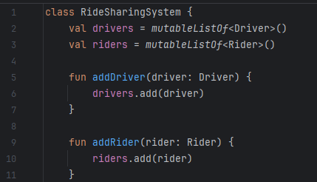

1. **assignRide(rider: Rider)**: This method matches a rider with the **closest available driver**. The **Haversine formula** is used to calculate the distance between the rider’s and driver’s locations. If two drivers are equally close, the system selects the one with the **highest rating**. The ride is assigned, and the rider’s status is updated to “Accepted.”

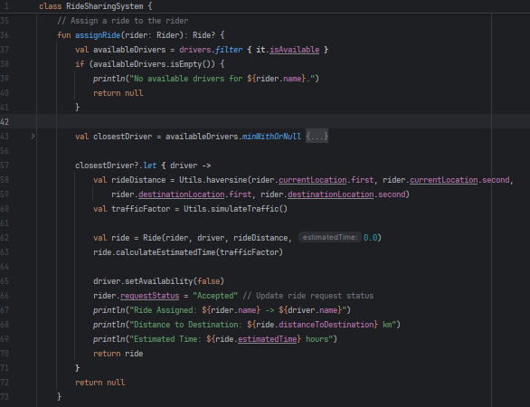

1. **rateDriver(driver: Driver, rating: Double)**: This method allows the rider to rate the driver after the ride is completed. The driver’s rating is updated as an **average** of previous and new ratings.

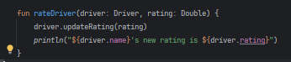

1. **displayDrivers()** and **displayRiders()**: These methods display all the drivers and riders in the system in a formatted table, including their current **availability** and **ride request status**.

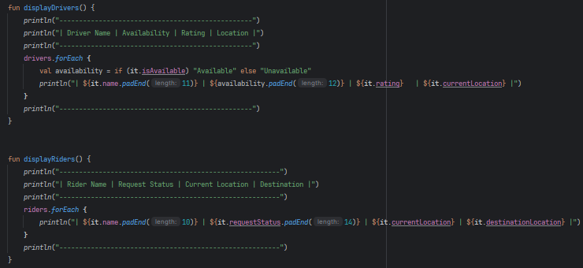

**Driver.kt**

The Driver class represents a driver in the system. It has attributes like the driver’s name, current location, availability, and rating.

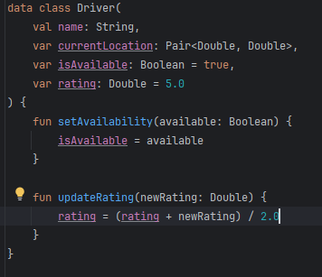

**Key Attributes**

* **isAvailable**: Tracks whether the driver is available for a new ride.
* **rating**: Tracks the driver’s current rating, which gets updated after each ride.

**Rider.kt**

The Rider class represents a rider in the system. The rider has attributes for the current location, destination, and ride request status.

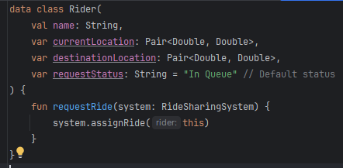

* **requestRide ()**: Initiates the ride request process by calling the assignRide() method of the RideSharingSystem.
* **requestStatus**: Tracks whether the rider’s ride is “In Queue” or “Accepted.”

**Ride.kt:**

The Ride class represents a ride between a rider and an assigned driver. It calculates the distance between the riders’s starting location and destination, as well as the estimated ride time based on traffic conditions.

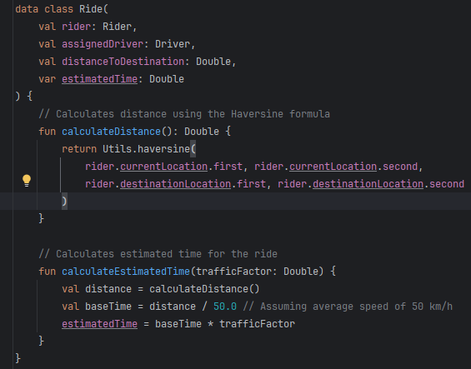

**Utils.kt**

This file contains utility functions, such as the **Haversine formula** to calculate the distance between two geographical points and a **traffic simulator** to simulate real-world traffic delays.

1. **haversine()**: This formula calculates the distance between two locations on the Earth given their latitude and longitude.

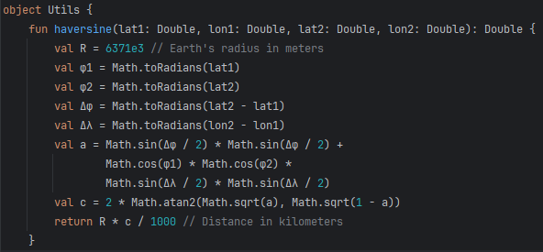

1. **simulateTraffic()**: This function simulates traffic delays by generating a random traffic factor between 1.0 and 2.0.

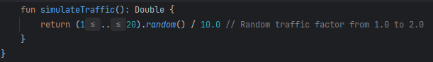

**Special Features & Kotlin Specifics:**

1. **Data Classes**: Kotlin’s **data classes** are used to create Driver, Rider, and Ride classes. These provide built-in features like equals (), hashCode (), and toString().
2. **Null Safety**: The system uses Kotlin's **null safety** features, such as the ?.let construct, to avoid null pointer exceptions when assigning rides.
3. **Comparator Functions**: The **minWithOrNull** method is used to compare drivers based on both **distance** and **rating**. This method allows multiple criteria for driver selection in a concise way.

**CONCLUSION**

This project provides a robust **Smart Ride-Sharing System** that manages drivers, riders, and ride assignments based on proximity and traffic conditions. By leveraging Kotlin’s advanced features such as **data classes**, **null safety**, and concise **comparator functions**, the system is highly modular, easy to maintain, and efficient.

The system effectively allows users to interact through a simple console interface, where they can add drivers and riders, request rides, and rate drivers. Additionally, the use of the **Haversine formula** ensures accurate distance calculations between the rider and driver locations, while the **traffic simulation** adds realism by introducing variable ride times. The system also updates rider statuses and driver availability dynamically, making it practical for real-world use cases.

Overall, this project demonstrates how Kotlin can be used to create a fully functional, interactive ride-sharing system that handles complex logic while remaining user-friendly and efficient.

OUTPUTS ARE ATTACHED IN A PDF FILE.